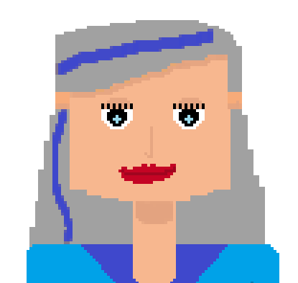Dr. Yvonne Marie Lefebvre

D.O.B 04.08.1960

Adress 94 Old Lane, 60064 Portlane

Tel. +56089045

Email [ladyart@yahoo.com](mailto:ladyart@yahoo.com)

Education

Ph.D. in History of arts, Sandford University

Master’s Degree in History of arts, La Sapienza (Rome)

Bachelor’s Degree in History of arts, Sorbonne (Paris)

Diplôme supérieur d'art plastique, École nationale supérieure des beaux-arts (Paris)

Working Experience

2000 – 2020 Director of *Atelier des arts* *Gallery*, New York

Letter of motivation

“…working with children has always been a dream of mine, teaching seems to be a natural progression from my years of directing a successful art gallery and helping young, talented artists to find their place in the world. Pupils should be able to express themselves freely in a warm and welcoming environment, where creativity is the only guide…”